ESP32-S3-MINI Custom Development Board
4-layer embedded controller board with USB-C, USB-to-UART, power regulation, and GPIO breakout
https://github.com/harolu44-cpu/ESP32-S3-MINI-Custom-Development-Board

Overview
I designed a custom ESP32-S3-MINI development board using Altium Designer to create a compact embedded platform with the support circuitry needed for programming, power, and external I/O. The board integrates dual USB-C connections, one of which is connected to UART. It also includes 5V and 3.3V power regulation, boot and reset controls, status LEDs, and breakout headers for the ESP32 GPIO.
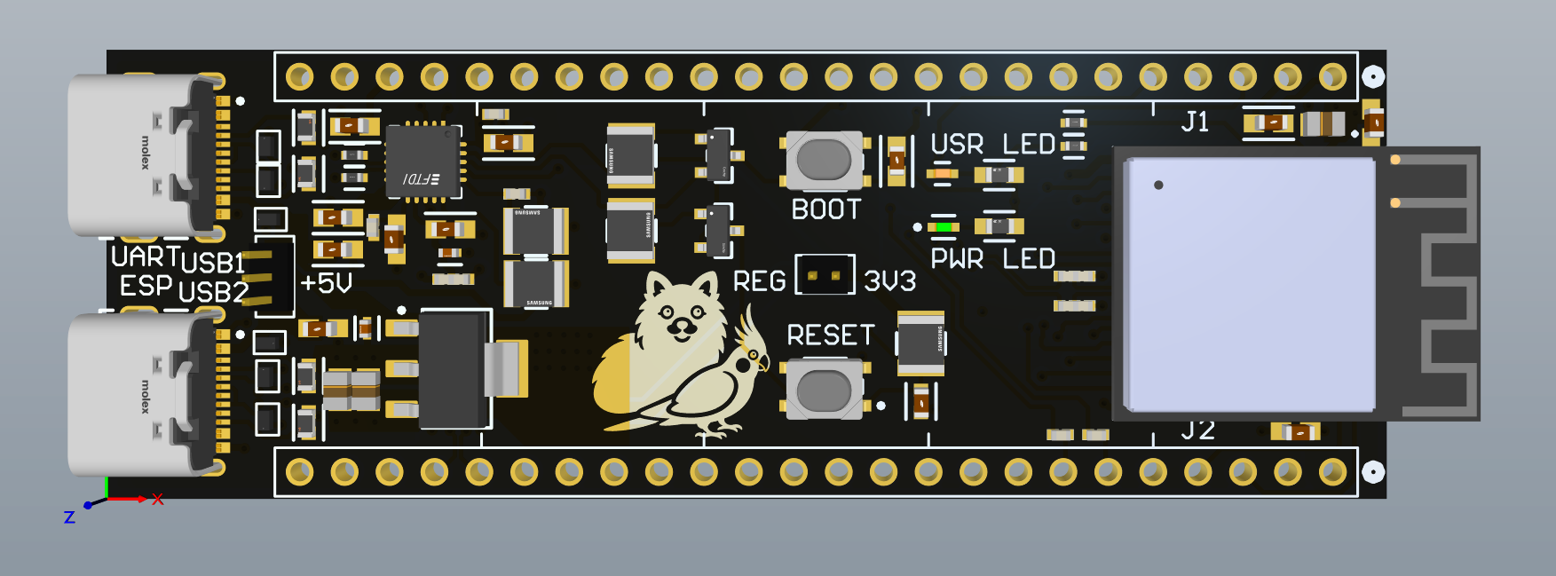

Hardware
The ESP32-S3-MINI module is the center of the board, with circuitry for USB connectivity, serial programming, power conversion, user controls, and GPIO breakout. The schematic is organized into functional blocks so each interface can be reviewed before PCB layout. The four-layer PCB provides additional routing space and copper for cleaner power and signal distribution.

Build Process

1. Requirements and Block Planning
The first thing I did in designing this board was lay out what I wanted to do which was a general purpose ESP32 board with Wi-Fi. To start I looked at different schematics that were based around this module and selected how I would wire and make the schematic myself based upon the designs.

2. Schematic Capture
I created the schematic in Altium designer and organized it into two USB-C sections one of them is also connected to the UART module. Next was the 5V and 3.3V power selection and regulation. After this I did the LEDs and Boot/Reset buttons. The last part that was needed for the schematic was the headers connected to the ESP32 module to be able to use the GPIO pins.
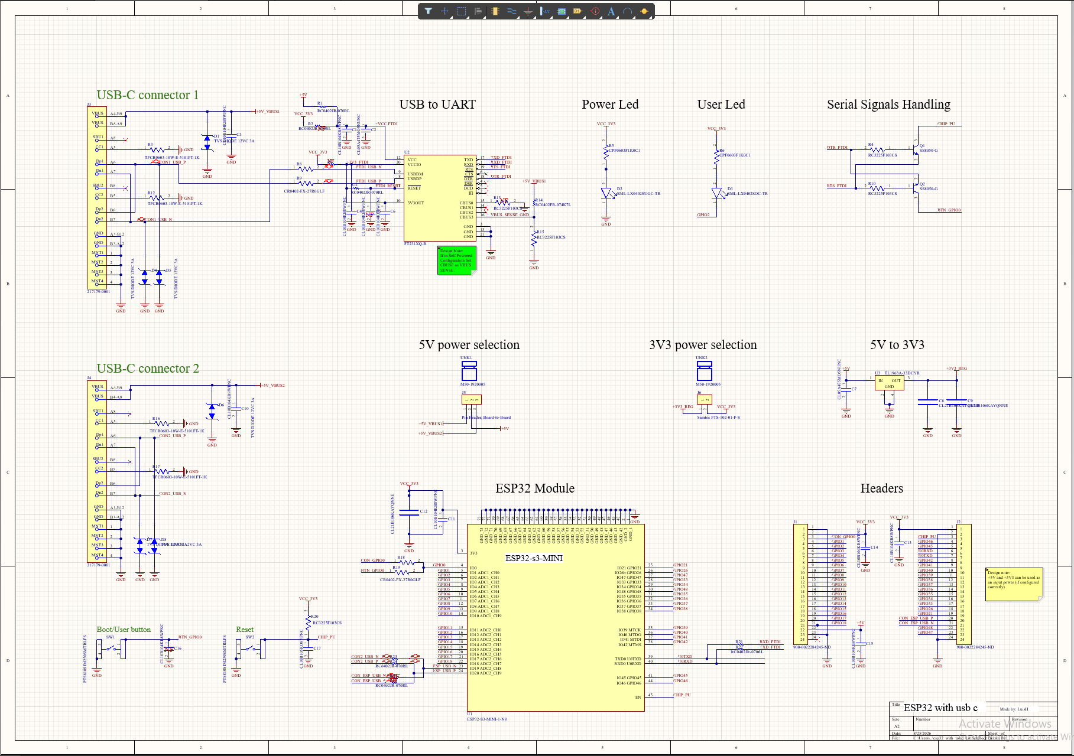

3. Component Placement and Floor planning
I placed the two USB-C connectors along the board edge which is common practice for these boards or any. Next I grouped the UART with the USB-C it was connected to so the wires didn’t need to travel a large amount. After this I positioned the ESP32 so its antenna remained on the outer edge of the PCB so nothing would interfere with it. Lastly I put the two headers on each side and marked were pin 1 was and put all the rest of the components close to the main components they were connected to especially the capacitors.

4. Four-Layer Stackup (Signal, Power, Ground Strategy)
For this boards layout I looked at multiple different boards and decided to go with for the first layer making that a layer for signals while the second layer is strictly for power to help transfer it from one component to another and for the third layer I made this a ground plane to connect all the ground to each other and help with some noise possibly. Lastly the last layer was also a signal layer because one signal layer was not enough with all the components needed to fit onto this board.
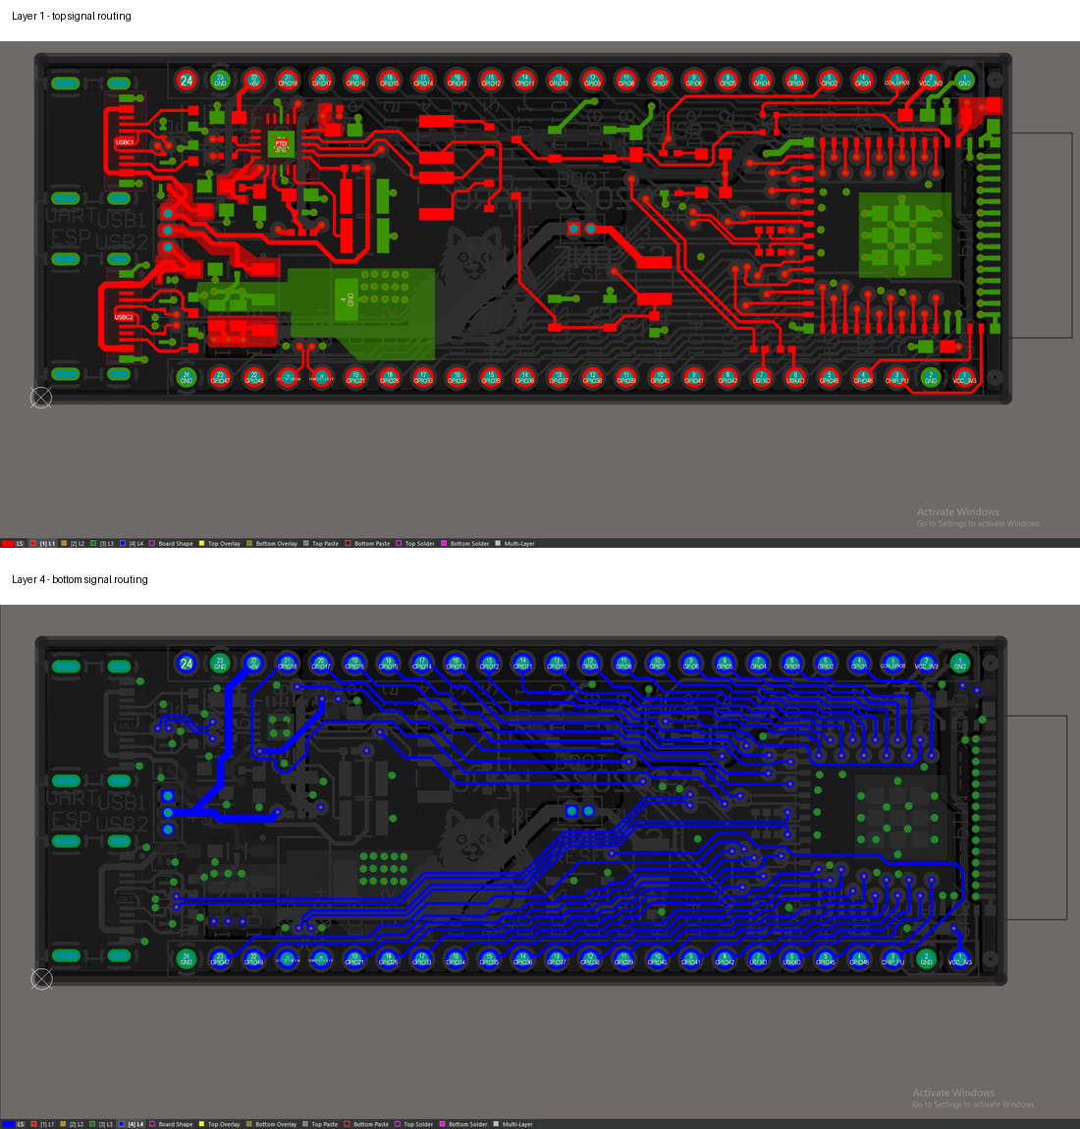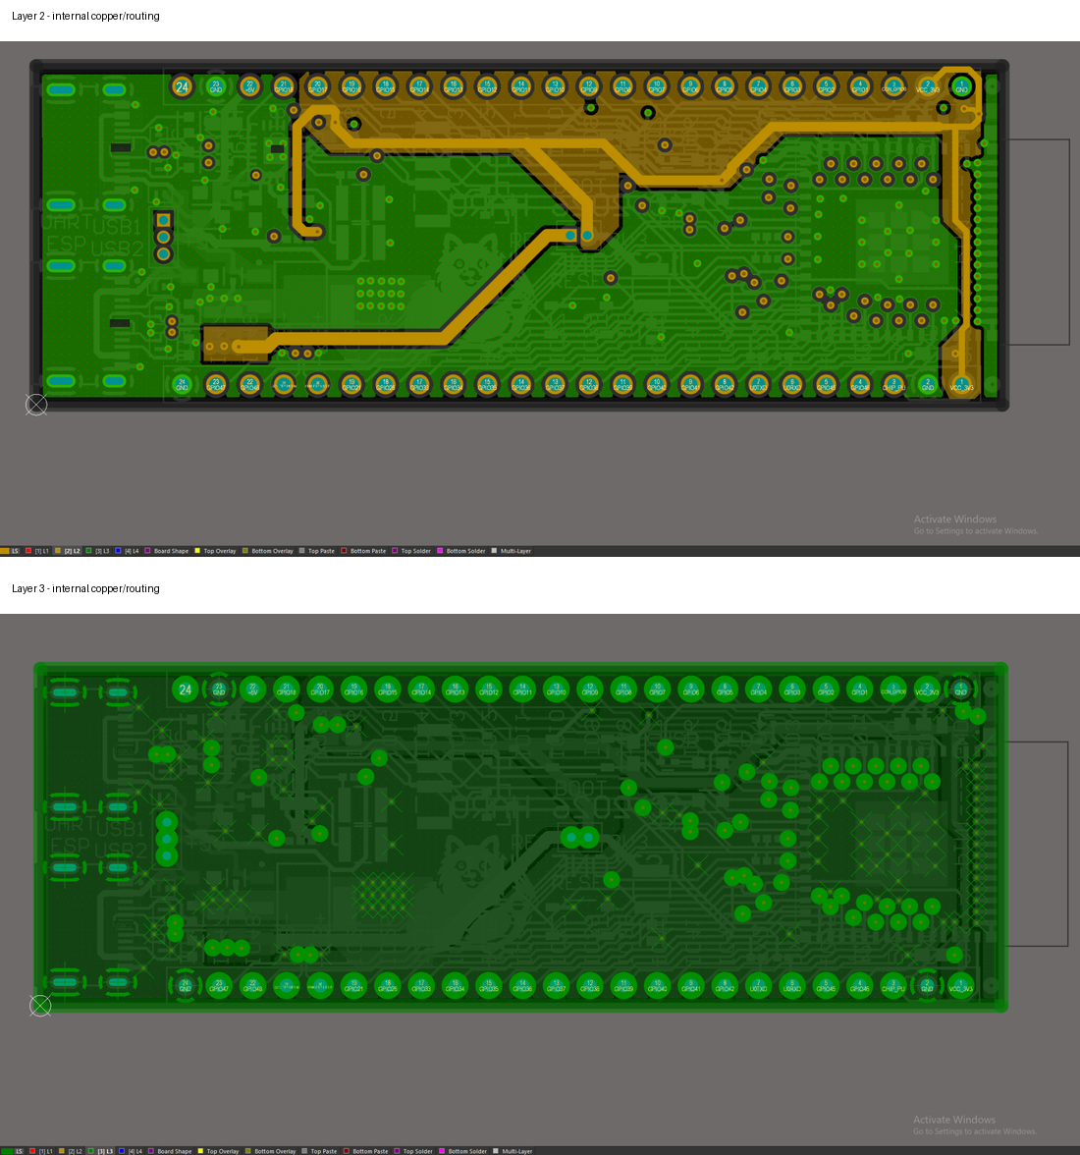

Design Rule and Reproducible Manufacturing Outputs
This board is not only to show I am competent in PCB design but also for personal use as a development board I use in other projects so I wanted it to be able to be manufactured by a PCB manufacturer and put together. For this to happen you need to follow strict guidelines given to you by the manufacturer to adhere to the machines that will be producing this. Some examples of this is for the USB-C we need the tracks to have 90 ohms impedance so for this we need to go to a impedance calculator in my case JLCPCB’s one and select the board type I will be using and what impedance I need and it will give me track spacing and width. Another example of this is the thickness of the board and how close each component can be placed to one another. This you need to follow or the board you order will not come out as expected and to check this Altium provides rules you can change and rule checks. These rule checks flag everything that is wrong and you will have to fix it which is one of the most time consuming parts of PCB design however once this is done your PCB will be complete.
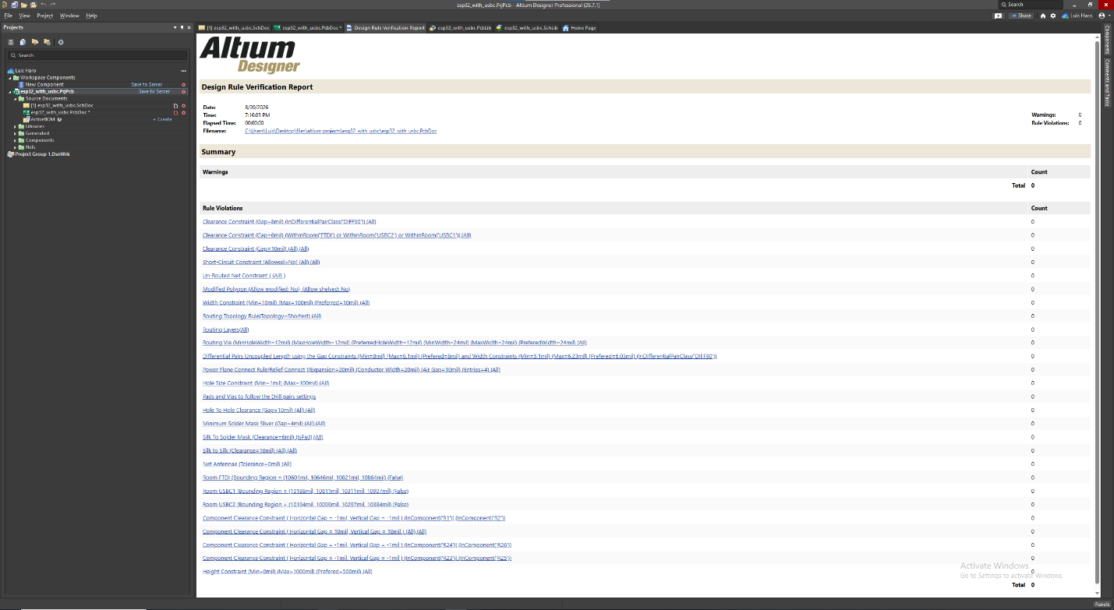

Key Skills Demonstrated
- Altium Designer Schematic capture, PCB layout, and design-rule checking
- ESP32 Hardware integration and embedded development-board architecture
- USB-C and USB-to-UART interface
- 5V/3.3V power regulation and distribution
- Four-layer routing, via usage, copper pours, and GPIO breakout planning
- Component libraries, footprints, 3D models, and BOM management
- Gerber, Drill, Boom, and pick-and-place generation for fabrication

Lessons Learned
This project gave me a better understanding of the complete PCB workflow from schematics to architecture, component footprints, multilayer routing, design-rule verification, and manufacturing files. I learned how strongly placement decisions can affect the routing and its quality and how power, USB, and antenna clearance and placement play a big factor in how well your board performs.

